

**APPLIED PROJECT 2**

**Asia Pacific College Violation System**

Project

Presented to the

School of Information and Computing Technologies

Asia Pacific College

3 Humabon Place, Magallanes Makati City

John David Solomon

Ren Daryl Gomez

Dody Alkarim

Cristian Andrew Mendoza

August 7, 2019

TABLE OF CONTENTS

INTRODUCTION 3

Project context 3

Purpose and Description 4

Description of Target Market 5

Scope and Limitation 5

Project Objectives 5

Related Literature 6

Related Systems 7

TECHNICAL BACKGROUND 8

Technical Aspects 8

Diagrams 9

Context Flow Diagram 9

Data Flow Diagram 10

Use Case Diagram 11

Use Case Full Description 12

Activity Diagram 18

Entity Relationship Diagram 23

Class Diagram 24

Object Diagram 25

Sequence Diagram 26

Event Table 31

requirements and initial design 32

Initial canvas 32

Gap Analysis 32

Pain Points 32

References 33

**INTRODUCTION**

1. **Project Context**

Asia Pacific College is a premier educational institution that aims to develop well-equipped graduates. Aside from comprehensive educational programs, discipline and training plays a huge role in molding the students into young professionals. This is accomplished through setting rules and regulations to cultivate the students’ a genuinely good and professional character. A violation is issued to students who disobey or defy these rules. The process of issuing violations is the foundation of discipline and character at Asia Pacific College.

Most of these violations are issued by the school guards. To issue the violation, guards inform the student the rules they violate, ask them to write their name, student ID number, course and section twice, and write the nature, date and time of violation. This is a tedious and time-consuming task both for the issuer and the student. Cancelling a violation is another difficult task. Students must consult the Disciplinary Office and if the cancellation is approved, show the violation slip issued. This means that once the violation slips from the guards are submitted to the Disciplinary Office, the officer-in-charge must countersign the violation slip issued by guard to complete the cancellation process.

Shifting the attention to the students, lack of notification or information has always been denounced by the students.

1. **Purpose and Description**

The project aims to address the violation system issues and alleviate the burden of the students, issuer, and disciplinary officer. All the stakeholders can use the application to perform appropriate functions. Also, they, except for the students, can easily issue a violation. The students can only view the violations issued to them and the disciplinary officer can cancel and view violations. Students are also notified through SMS whenever a violation is added to their account. The application improves the speed, efficiency and accuracy of issuing violations.

To issue a violation, authorized stakeholders must enter the student’s ID number, name, mobile number, and the nature of the violation. Once submitted, a timestamp is automatically added to the record. Students would then receive a SMS notifying them of the violations issued to them.

The disciplinary officer handles the cancellation of student violation. He can also delete violations using the student’s unique ID number. The violations issued to the student within the day are then deleted but the data will be archived by the disciplinary officer.

The students and the disciplinary officer can view violations by searching using the student's ID number. If the search is successful, the student’s last name, first name, course and photo are displayed alongside the records of violations issued to them.

1. **Description of Target Market**

Generally, the target market of the violation system are schools, but the project is designed and developed to bring innovation to the current violation system of Asia Pacific College.

All the stakeholders of the project are internal, which involves:

* Students
* Disciplinary Officer
* Guidance Counselors
* Executive Director
* Security Guards
* Professors

The project is a mobile application taking advantage of its portability and making it accessible instantly for stakeholders who will interact with the application.

1. **Scope and Limitations**

When it comes to the violation system, the Asia Pacific College still uses the manual violation system regarding the violation of school policies. That is why the team decided to innovate the violation system of the school.

The project will be based on a mobile application only, making it convenient to stakeholders through their mobile while the facility personnel uses the web application for better a view of the violations. The mobile application will be available in Android devices only. The system provides a portal for the quick implementation of violation for the stakeholders who want to issue violations to APC students anywhere in the school whenever there is a violation of school policies. It will give the disciplinary officer, guidance counselors and students a detailed information on every violation that will be stored in the system. The detailed information is composed of the student's unique ID number, name, nature of violation and the students phone number. All stakeholders are required to create an account before using the application. Students will be able to see the list of their violations through the application. Using the application requires internet to store the data and manipulate that data for the other stakeholders. Assigning different roles depends on the user during registration. The data will go through validation to make sure proper designation of roles.

.

1. **Project Objectives**

**General:** To develop a mobile application that automates the process of adding, deleting and monitoring violations issued in Asia Pacific College.

**Specific:**

* To provide an interface for stakeholders to register and log in and out of the account.
* To create an interface for adding and deleting violations.
* To create real-time violation tracker accessible by the students.
* To notify the students about violations issued to them using SMS.

**RELATED LITERATURE AND SYSTEMS**

This chapter has the different literatures and systems that will help our team better understand the importance of our project. This project focuses on the innovation of how to issue a violation. This chapter will also serve as our guide to implement new features for our project.

1. **Related Literature**

Smart Recording of Traffic Violation System is an RFID and NFC based technology that intelligently registers drivers’ violations without having to engage with a traffic law enforcement. The system eliminated a lot of process in issuing a traffic violation which is related to what this projects goal. (Mohamed, S. A. (2019). Automatic Traffic Violation Recording and Reporting System to Limit Traffic Accidents: Based on Vehicular Ad-hoc Networks (VANET). 2019 International Conference on Innovative Trends in Computer Engineering (ITCE). doi:10.1109/itce.2019.8646449)

An on-board unit is securely placed inside the vehicle and the device main goal is to record and report the violations real time. Like the device used in the paper represents the mobile phone in this project which makes it easy to issue a violation to students. (Nejati, Omid & Yaghoubi Suraki, Mohsen. (2012). NFC : Smart Recording Of Traffic Violation System.)

The objective of the application is to develop an urban freight transport violation reporting application. It generates real-time information to monitor the freight transport in Surakarta City. Cost, practicality and convenience is the advantage of the said application which we also want to implement so that the school benefits from the project. (Yulianto, B., & Setiono. (2018). Implementation of android-based urban freight transport violation reporting application in Surakarta city. doi:10.1063/1.5042948)

The study addresses the problems correlated in using papers in document. With digital paper information dissemination is effortless. Results will be instant, productivity increases while cost decreases. (Harrold, Dave. (2000). Digital paper. 47. 100, 102, 104.)

It discusses the importance of information systems in management. The violation system gives new value to the data making it valuable not only to the disciplinary officers but also to other parties involved in the system. (Obasha, Henry & Aliu Akhamiokhor, Clifford. (2019). INFORMATION SYSTEM. Journal of Information. 1-18.)

1. **Related Systems**

Student Violation Monitoring System is a system that records all the violations of the students of Asian College. This system will benefit the administrators of the school to record all the violations of the students with ease. (https://www.coursehero.com/file/31934314/Student-Violation-Monitoring-Systemdocx/)

Student Violation and Security Monitoring System is a system that will provide and process record in accordance with the students’ violations and students’ logs. This system will help STI College Southwoods' SSO (Student Services Office) problem of the number of students having an increase of violations. (https://prezi.com/6cbah0mglt0h/student-violation-and-security-monitoring-system/)

OSPS Offense Monitoring System is a system that monitors or records the offenses of each student enrolled or studying in CIC (College of the Immaculate Conception). This system aims to make it easy in monitoring the offenses of each student. (https://prezi.com/halbra_v1hkb/osps-offense-monitoring-system/)

A Proposed Offense Monitoring System with Notification via SMS -This proposed system is for the DO (Discipline Office) of STI College Novaliches where they will be the ones who will monitor the students' offenses, their statuses, and sanctions. This system will also send a notification via SMS (Short Message Service) directly to the parents of the student if they get a major offense or excessive number of violations. (https://prezi.com/wq7j_h3uwgbx/a-proposed-offense-monitoring-system-with-notification-via/)

Student Violation Record System is an identification system that will provide and process records in accordance with students' violations and logs. This is system is for students of San Sebastian College Recoletos Canlubang (SSCR) that uses a SMS (Short Message Service) technology to inform the parents of the student of the violation the student committed. (https://prezi.com/wtplc9o5qlgu/student-violation-record-system/)

**TECHNICAL BACKGROUND**

1. **Technical Aspects**

**A. Android Studio**

Integrated Development Environment (IDE) is a software that allows developers to write and test software. The Integrated Development Environment (IDE) has the basic tools like code editor, compiler or interpreter, debugger, and automation tools that can lessen the developer’s work. IDE can improve developer’s productivity since it covers all programming tasks in one application. It saves developers time, speeds up development tasks, keeps the developer up to date and even standardizes the process of development.

An example of an integrated development environment (IDE) is Android Studio. Android Studio is the software built by JetBrains for Google to be used for Android Development. Android Studio has built automation, dependency management, and customizable build configurations like other IDE’s out there in the market today. Android Studio provides a unified environment where you can build apps for Android phones, tablets, Android Wear, Android TV, and Android Auto. Structured code modules allow you to divide your project into units of functionality that you can independently build, test, and debug. Android Studio integrates with version control tools, such as GitHub and Subversion, collaborating with the project team while you build changes.

**B. Java**

Java is one of the world's most important and widely used computer languages, and it has held this distinction for many years. Java was developed by James Gosling, Patrick Naughton, Mike Sheridan at Sun Microsystems Inc. in 1991. It took 18 months to develop the first working version. It was first named Oak, but it was renamed to Java in 1995 as OAK was a registered trademark of another Tech company back then. Java is an open-source programming language, simple, secure, safe and codes are reusable.

**C. PHP**

PHP stands for Hypertext Preprocessor and is a widely-used open source language. Majority of websites whose server-side programming language runs on PHP.

**D. MySQL**

Problems that arise in an open-source technology can be eliminated with My SQL’s technical support. It makes maintenance, debugging and upgrades light and easy while enhancing the user experience.

1. **Diagrams**

**Figure 1. Data Flow Diagram**

**1.1. Context Diagram / Level 0**

**1.2. Level 1**

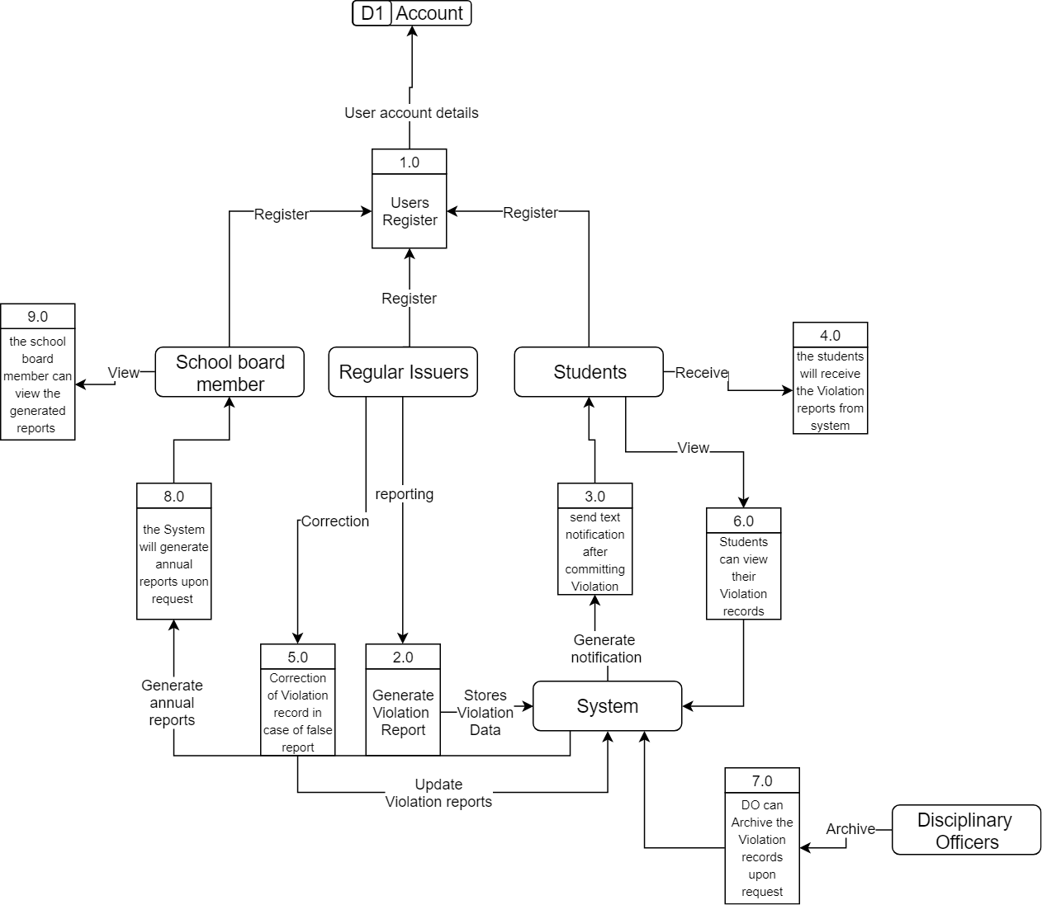

**Figure 2. Use-Case Diagram**

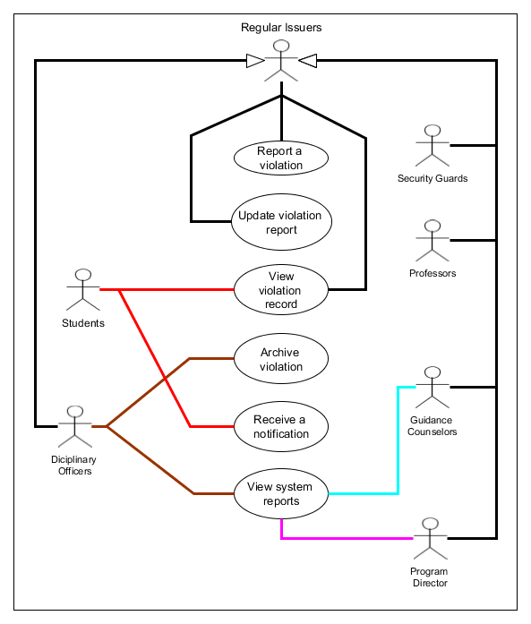

* 1. **Use-Case Full Description**

**2.1.1.**

|  |  |  |
| --- | --- | --- |
| Use Case Name: | Report a violation | |
| Scenario: | Security Guard, Professor, Program Director, Disciplinary Officers and Guidance Counselors issues a violation | |
| Triggering Event: | Student violates school policy | |
| Brief Description: | A school policy was violated, and it is categorized as minor and major offense. | |
| Actor/s: | * Regular Issuers | |
| Related Use Case: | - | |
| Stakeholders: | * Regular Issuers | |
| Preconditions: | * Stakeholders must be logged in * Stakeholders must have internet access | |
| Post Conditions: | * Student received a notification via SMS | |
| Flow of Activities: | Actor/s | System |
| 1. Launched the app 2. Enters account credentials 3. Logs in 4. Adds violation record to student | * 1. Directs to Login Screen   2. System verifies credentials   3.1 Display APC Violation System home  4.1 System stores violation record and sends text message notification |
| Exception Conditions: | * Application is not launched. * Stakeholders has no account/unregistered. * Stakeholders entered incorrect credentials and is redirected to the Login Screen again. | |

**2.1.2**

|  |  |  |
| --- | --- | --- |
| Use Case Name: | View violation record | |
| Scenario: | View how many violations are unsettled or committed under the student’s id number. | |
| Triggering Event: | Authorize users view a violation record | |
| Brief Description: | Stakeholders either wants to see the violation record they issued or issued to them | |
| Actor/s | * Students * Regular Issuers | |
| Related Use Case: | - | |
| Stakeholders: | * Students * Regular Issuers | |
| Preconditions: | * Device must have internet access * Device must have carrier signal * Device must have credits for SMS | |
| Post Conditions: | * Device will automatically store the violation record and send a text message notification | |
| Flow of Activities: | Actor/s | System |
| 1.0 Launched the app  2.0 Enters account credentials  3.0 Logs in  4.0 Select view | * 1. Directs to Login Screen   2. System verifies credentials   3.1 Display APC Violation System home  4.1 Display violations |
| Exception Conditions: | * Stakeholders phone is not connected to the internet * Stakeholders has no account/unregistered. * Stakeholders entered incorrect credentials and is redirected to the login screen again. | |

**2.1.3.**

|  |  |  |
| --- | --- | --- |
| Use Case Name: | Archive violation | |
| Scenario: | The violation record has been sorted out with the student and is now archived | |
| Triggering Event: | Archive violation request | |
| Brief Description: | The student and the disciplinary officer in charge archives the violation record after talking to the student. | |
| Actor/s | * Disciplinary Officers | |
| Related Use Case: | View violation record | |
| Stakeholders: | * Disciplinary Officers | |
| Preconditions: | * Violation must be settleable * Discipline officers and student must have a conversation first | |
| Post Conditions: | * Record should now be gone in students record or view. * The violation record has been soft-deleted. | |
| Flow of Activities: | Actor/s | System |
| 1.0 Stakeholders archives the students record | 1.1 System soft-deletes the violation record |
| Exception Conditions: | * The student has no account. * The student has no record to archive | |

**2.1.4.**

|  |  |  |
| --- | --- | --- |
| Use Case Name: | Receive a notification | |
| Scenario: | One of the regular issuers reported a violation | |
| Triggering Event: | Stores violation data | |
| Brief Description: | Whenever a student is reported through the application it will automatically notify that student through a text message. | |
| Actor/s | * Students | |
| Related Use Case: | Report a violation | |
| Stakeholders: | * Students | |
| Preconditions: | * Students must have the correct mobile number stored in the database * Device must have carrier signal * Device must not be on Airplane Mode | |
| Post Conditions: | * Notification should be received by the student | |
| Flow of Activities: | Actor/s | System |
| 1.1 Receive text message notification | 1.0 System sends a notification to the reported student. |
| Exception Conditions: | * Students phone was stolen or missing * No carrier signal | |

**2.1.5.**

|  |  |  |
| --- | --- | --- |
| Use Case Name: | Update violation report | |
| Scenario: | The discipline office updates the violation record | |
| Triggering Event: | Reported wrong student or details | |
| Brief Description: | The authorize user that can report or issue a violation made a mistake | |
| Actor/s | * Regular Issuers | |
| Related Use Case: | Report a violation | |
| Stakeholders: | * Regular Issuers | |
| Preconditions: | * Stakeholders must be logged in * Stakeholders must have internet access | |
| Post Conditions: | * Updates violation record of the student in the database | |
| Flow of Activities: | Actor/s | System |
| 1. Reports a violation   2.0 Notices an incorrect detail and corrects the report.  3.0 Submit the report | * 1. Displays the detailed report before submitting   3.1 System store the violation record in the database |
| Exception Conditions: | * App is not launched. * Stakeholders doesn’t have an account * Stakeholders submitted the report and did not review the violation report * Stakeholders submitted the report and did not edited the incorrect detail/s | |

**2.1.6.**

|  |  |  |
| --- | --- | --- |
| Use Case Name: | View system reports | |
| Scenario: | System generates reports | |
| Triggering Event: | Discipline Office, Guidance, Program Directors and Professors requests for System Reports | |
| Brief Description: | The application will generate system reports | |
| Actor/s | * Disciplinary Officers * Guidance Counselors * Program Director | |
| Related Use Case: | - | |
| Stakeholders: | * Disciplinary Officers * Guidance Counselors * Program Director | |
| Preconditions: | * Stakeholders must be logged in * Stakeholders must have internet access * There should be violation records | |
| Post Conditions: | * Generated system reports | |
| Flow of Activities: | Actor/s | System |
| 1.0 Launched the app   1. Stakeholders enters account credentials 2. Stakeholders logged in   4.0 Stakeholders view violation records  5.0 Stakeholders view the generated system reports | 1.1 Directs to login screen   * 1. System verifies credentials   3.1 Display APC Violation System home    4.1 Display violation records  5.1 Display system reports of violations in APC. |
| Exception Conditions: | * App is not launched. * No account * Stakeholders entered incorrect credentials. * Stakeholders is redirected to the login screen again. * There are no violation records at all. | |

**Figure 3. Activity Diagram**

**3.1.**

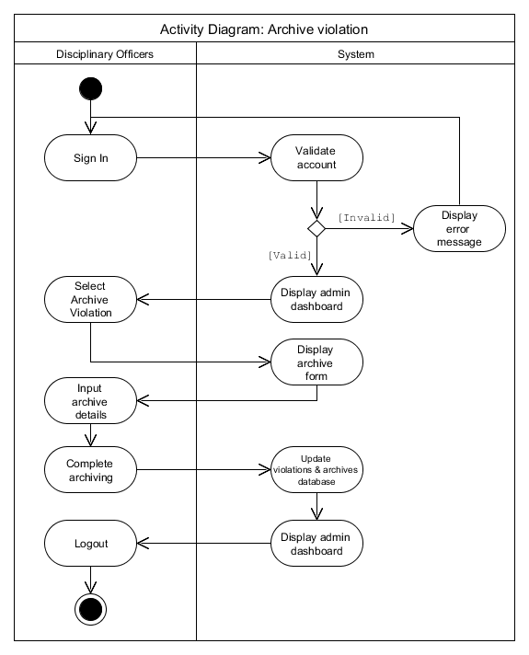

**3.2.**

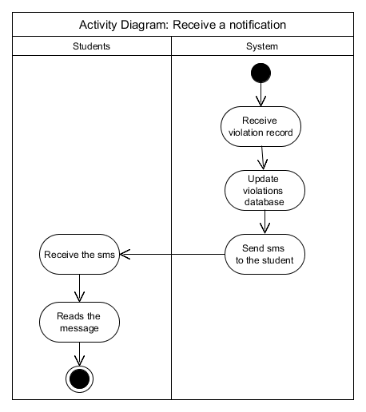

**3.3.**

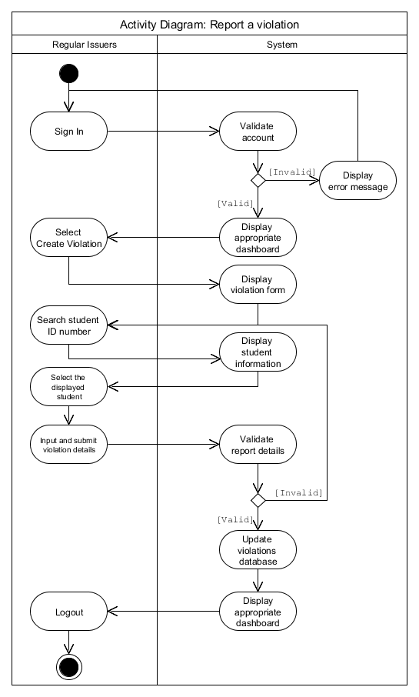

**3.4.**

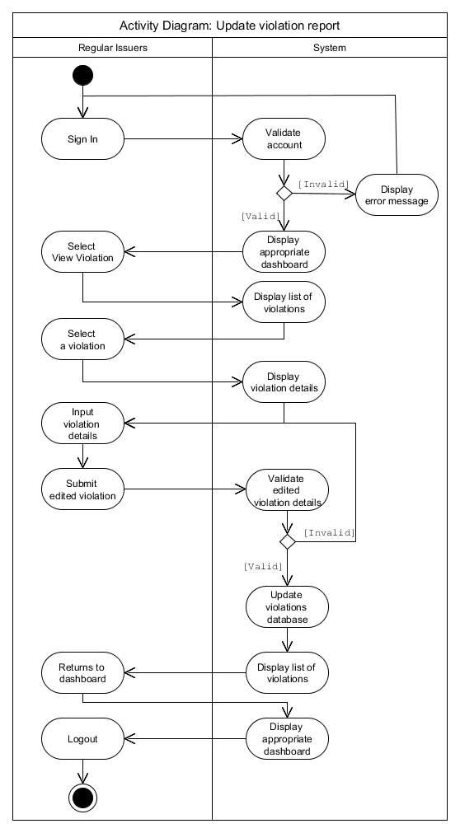

**3.5.**

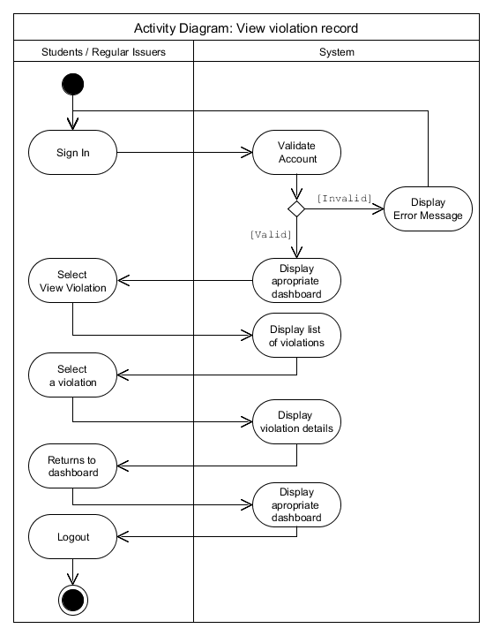

**Figure 4. Entity-Relationship Diagram**

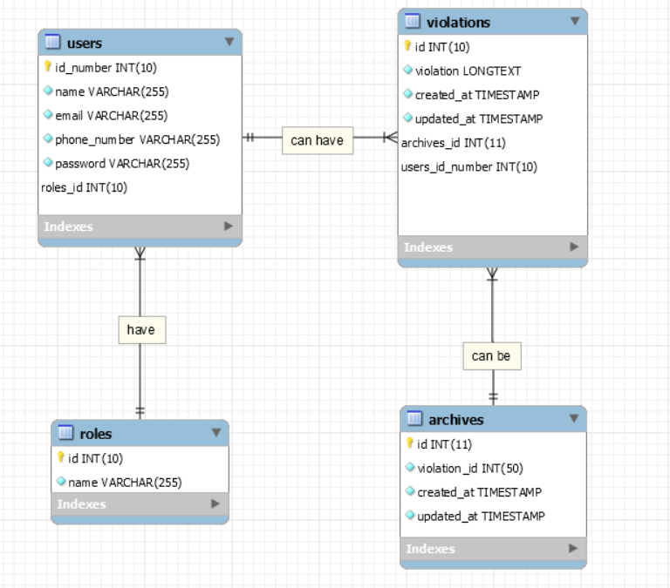

**4.1. Business Rules:**

**1. One or many USERS have only one ROLES.**

**2. One student USERS can have one or many VIOLATIONS.**

**3. A Disciplinary Officer USERS can ARCHIVES one or many VIOLATIONS**

**4. One or many VIOLATIONS can be ARCHIVES**

**5. One or many USERS have only one ROLES**

**6. One student USERS can have one or many VIOLATIONS**

**Figure 5. Class Diagram**

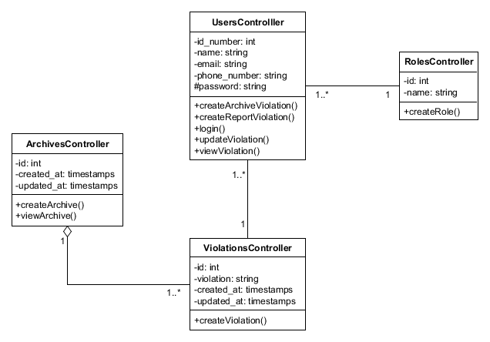

**Figure 6. Object Diagram**

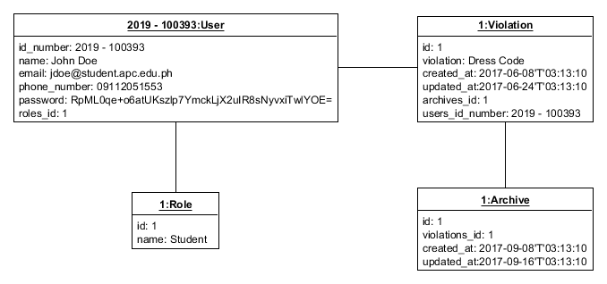

**Figure 7. Sequence Diagram**

**7.1.**

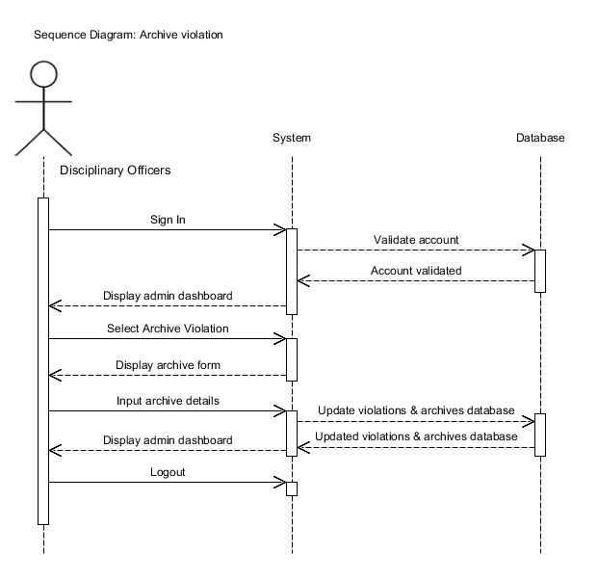

**7.2**

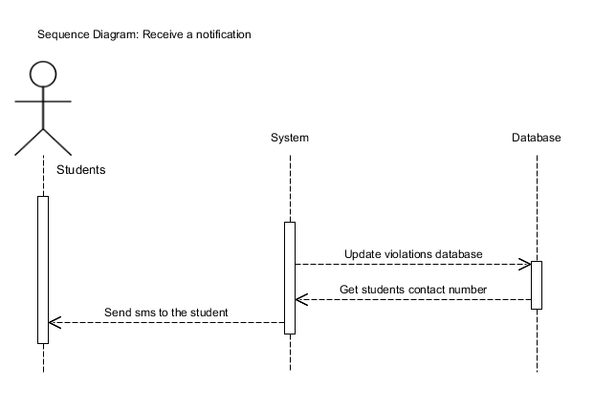

**7.3.**

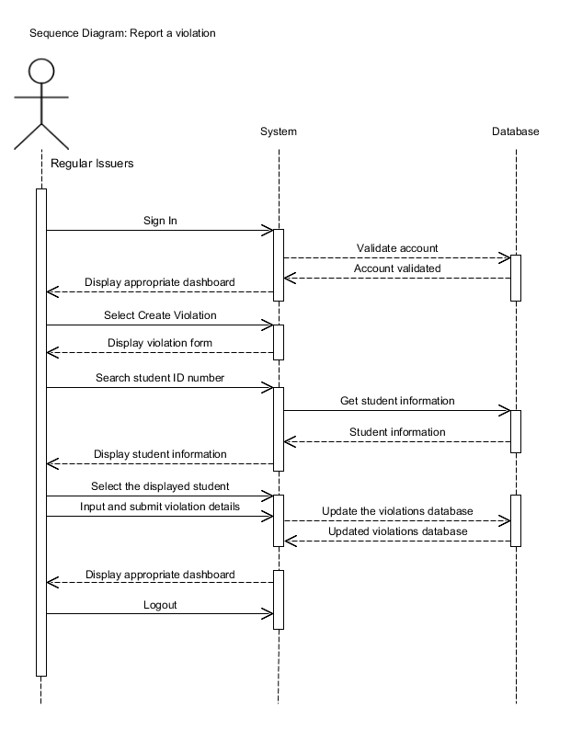

**7.4.**

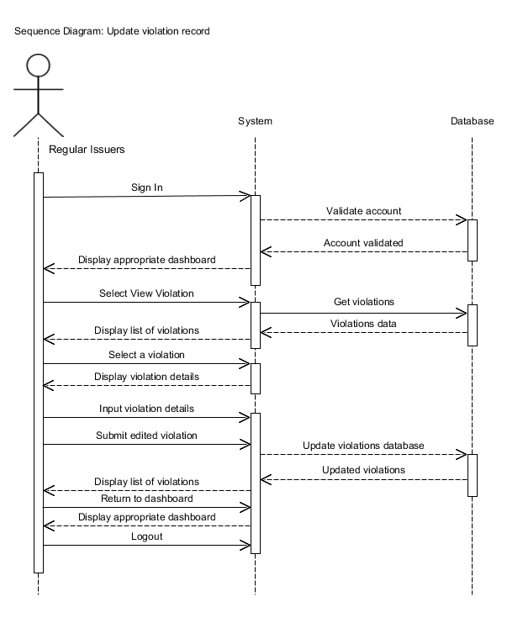

**7.5.**

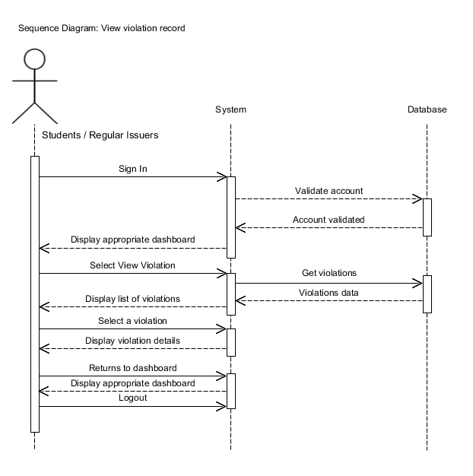

**Figure 8. Event Table**

|  |  |  |  |  |  |
| --- | --- | --- | --- | --- | --- |
| Event | Trigger | Source | Use Case | Response | Destination |
| Reporting of violation | Student violates school policy | * School Guards | Report a violation | Stores violation data | * System * Students |
| Correction of violation | Reported wrong student | * School Guards * Disciplinary Officer | Update violation report | Updates database | * System * Students |
| Notification of violation | Stores violation  data | * System | Receive a notification | Receives a notification | * Students |
| Viewing of violation record | Student views a violation record | * System | View violation record | Display violation record | * Students * School Guards |
| Archiving of violation | Archive violation request | * Disciplinary Officer | Archive violation | Update violations and archives database | * System * Students |
| Generate reports | Request for system reports | * System | View system reports | View generated reports | * Disciplinary Officer * Guidance Counselors * Program Director |

**REQUIREMENTS AND INITIAL DESIGN**

1. **Initial Canvas (Pain Points / Features / Situational Benefits)**

**GAP ANALYSIS**

|  |  |  |  |
| --- | --- | --- | --- |
| **Requirement** | **Current State** | **Proposed** | **Impact** |
| Create a system for issuing violations | Violations are redundant and inconvenient because of number of process | Develop an application to become an online violation system | The school will no longer have to endure the manual process of violation system. |
| Make the students become aware of their violations | Students are not aware of their violations like the number and nature of it | An SMS is sent to the student to notify them of the issued violation | Students will be aware and be notified of their violations |
| Students should be able to view their violations | Students are only given slips by the school guards | An interface for the students to view all their violations | Students will be able to see and be notified of all their issued violations |

**Pain Points**

* **Issuing of violations is time-consuming.**
* The number of process when issuing a violation to students is redundant and inconvenient.
* **Cancelling a violation.**
* Students must consult the Disciplinary Office and if the cancellation is approved, show the violation slip issued. This means that once the violation slips from the guards are submitted to the Disciplinary Office, the officer-in-charge must find and countersign the violation slip issued by guard to complete the cancellation process.
* **Lack of notification or information**
* Most students who receive sanctions states that the sanctions are either unexpected or mistaken. There is no way for the students to track the number and nature of violations.

**REFERENCES**

Nejati, Omid & Yaghoubi Suraki, Mohsen. (2012). NFC : Smart Recording Of Traffic Violation System.

Mohamed, S. A. (2019). Automatic Traffic Violation Recording and Reporting System to Limit Traffic Accidents: Based on Vehicular Ad-hoc Networks (VANET). 2019 International Conference on Innovative Trends in Computer Engineering (ITCE). doi:10.1109/itce.2019.8646449

Yulianto, B., & Setiono. (2018). Implementation of android-based urban freight transport violation reporting application in Surakarta city. doi:10.1063/1.5042948

Harrold, Dave. (2000). Digital paper. 47. 100, 102, 104.

Obasha, Henry & Aliu Akhamiokhor, Clifford. (2019). INFORMATION SYSTEM. Journal of Information. 1-18.

PrivateNeutronScorpion112. (n.d.). Student Violation Monitoring System.docx - Student Violation Monitoring System Student Violation Monitoring System is a system to record all violations: Course Hero. Retrieved from https://www.coursehero.com/file/31934314/Student-Violation-Monitoring-Systemdocx/

Catapang, F. (2019). student violation and security monitoring system. [online] prezi.com. Available at: https://prezi.com/6cbah0mglt0h/student-violation-and-security-monitoring-system/

Sebastian, C. (2011, August 12). OSPS OFFENSE MONITORING SYSTEM. Retrieved from https://prezi.com/halbra_v1hkb/osps-offense-monitoring-system/

Collado, J. (2013, October 20). "A Proposed Offense Monitoring System with Notification via. Retrieved from https://prezi.com/wq7j_h3uwgbx/a-proposed-offense-monitoring-system-with-notification-via/

Sanchez, L. (2016, February 18). Student Violation Record System. Retrieved from https://prezi.com/wtplc9o5qlgu/student-violation-record-system/

Class Diagram: Miles, R. and Hamilton, K. (2008). Learning UML 2.0. Sebastopol: O'Reilly Media,

Diaz, E. (2019, January 16). Is PHP Dead? Edwin Diaz. Retrieved from https://edwindiaz.com/is-php-dead/

Use Case Diagram: O'Docherty, M. (2005). Object-oriented analysis and design. Chichester, England: Wiley.

Object Diagram: Inc.GeeksforGeeks. (2018). Unified Modeling Language (UML) | Object Diagrams - GeeksforGeeks. [online] Available at: https://www.geeksforgeeks.org/unified-modeling-language-uml-object-diagrams/